**IST471 – GROUP 2**

**Classroom Assignment 1 (10 points)**

**Theme: Subqueries**

Instructions: Submit this classroom assignment via the **Dropbox** tool within **D2L**. One submission only for each team.

Note: You will earn a good portion of credit or a full score if you have put forth an adequate effort to answer the questions (even if some questions are not answered 100% correctly).

**Problem 1. (Debugging) Examine the following two queries and pinpoint the errors. How do you fix them?**

SELECT category, title, cost

FROM books

WHERE

cost >= SELECT cost FROM books WHERE title = 'DATABASE IMPLEMENTATION'

ORDER BY cost;

*--Added Parentheses around select statement*

SELECT category, title, cost

FROM books

WHERE

(SELECT cost FROM books WHERE title = 'DATABASE IMPLEMENTATION') <= cost

ORDER BY cost;

*--Put cost statement in the front, otherwise functions correctly.*

**Problem 2. Create a query to find out those computer books that were published after the book titled “HANDCRANKED COMPUTERS” was published. Sort the records in ascending order of pubdate.**

SELECT category, title, pubdate

FROM books

WHERE **pubdate > (select p**

ORDER BY pubdate;

*SELECT category, title, pubdate*

*FROM books*

*WHERE category = 'COMPUTER'*

*and pubdate > (select pubdate from books where title = 'HANDCRANKED COMPUTERS')*

*ORDER BY pubdate asc;*

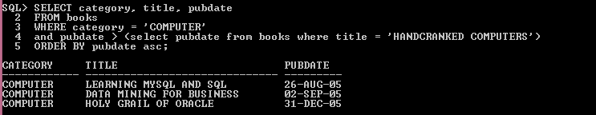

Expected result:

